**Tottenham vs Arsenal**

The FA Women’s Super League’s very first North London derby will see sixth host second, but table position may be secondary to rivalry.

Tottenham Hotspur may not have garnered as much attention as their fellow top-flight newcomers Manchester United, but they’ve built a reputation as a solid side, but one that wants to play attractive football.

Led by September Manager(s) of the Month Karen Hill and Juan Amoros, Spurs rarely take the direct, aerial route out of the back, and they average the fifth-most moves with ten or more passes per game in the league. Across the first five games, they’ve had just over 50% of possession too; not bad for a newly-promoted team.

Arsenal, though, are passmaestros in the extreme. While their North London rivals average 5.4 of those 10+ passing moves a game, Joe Montemurro’s Gunners get 22. They’re even averaging 3.6 moves with 20 or more passes, both figures the highest in the league by a distance.

This game, then, will likely be a case of Arsenal attack vs Tottenham defence, particularly because Spurs’ own attack is not that sharp. It’s intensely focused through Kit Graham and Rachel Furness, the pair being the only two players in the squad to have taken more than five shots across Tottenham’s opening five games (19 and 14 respectively).

Neither have been blessed with great chances though. From open-play, they’ve had opportunities worth just 0.74 and 0.57 expected goals for the whole of the league campaign. By comparison, Arsenal’s Vivianne Miedema averages 0.45 expected goals *per game*.

Yet even this is a step down from last season for Miedema, and for Arsenal as a whole – the Gunners have scored nine from their first five matches compared to the 27 in the first five in 2018/19. They are struggling to get the ball to Miedema in the box with the frequency they did last season, but the Dutch striker is still a force to be reckoned with.

Playing at home, at the new Tottenham Hotspur stadium, may help Spurs withstand this pressure, but it will be a tough task for their defence. A key may be left-back Siri Worm, who has one of the best rates of stopping wingers in their tracks in the league. Only two defenders in the WSL are harder to get past than her.

With that in mind, Arsenal may have more joy on the opposite flank. Tottenham right-back options Ashleigh Neville and Ria Percival both struggle when opponents have a run at them, and one of the pair will likely be up against Beth Mead, one of the England national team’s most-exciting attacking options.

In front of what is sure to be a bumper crowd, this local derby will be an atmospheric occasion, but one that the away side will be expected to dominate and to win – as they did, 6-0, in pre-season. But all of that would make it all the sweeter for Tottenham if they get a result.

**Liverpool vs Everton**

Merseyside derbies are, traditionally, fierce and tightly-contested affairs. On the men’s side, Everton haven’t won at Anfield in 20 years. This weekend could well see the club break that run, thanks to their women’s team.

Everton are a good side who have taken full advantage of a great run of form for 21-year-old forward Chloe Kelly. She’s the league’s topscorer on four goals and, deservedly, won the September Player of the Month award. Playing from the left wing, Kelly gets chances, runs at defenders, and wins free-kicks. A bit of a devil to play against.

Her goals have helped Everton to three wins (and a thoroughly entertaining 3-2 defeat to Reading), although it should be said that these three wins have come against some of the weaker teams in the league. As things look currently, the WSL is split, roughly, into three groups of four: the ‘Big Three’ of Chelsea, Arsenal, and Manchester City, as well as Manchester United; a midtable of West Ham, Everton, Tottenham Hotspur, and Reading; and then a lower tier of Brighton, Birmingham City, Liverpool, and Bristol City. Everton’s three wins have come against Brighton, Birmingham, and Bristol City.

But while Everton have three wins from five, their city rivals Liverpool are stuck to the bottom of the league on a single point. What’s worse, Liverpool are the only team in the league who are yet to play one of the ‘Big Three’ sides – those opening five matches, from which they’ve only gained one point, have all come against the ‘normal’ teams in the league.

It therefore looks troublesome for them going into the first women’s Merseyside derby played at Anfield.

There are some reasons for the Reds to be hopeful. Melissa Lawley, who joined from Manchester City in the summer, is a star at moving the ball up the field – it’s just that the team hasn’t yet been able to create consistent chances off the back of that.

Picking apart their results, there’s also a tenuous reason to hope. Their matches at home so far have been against Reading, one of the mid-table bunch, and their sole point, a draw against Bristol City. The other three matches have been away from home, and including tricky trips to Tottenham and Manchester United.

The long and short of it, though, is that Liverpool are yet to keep a clean sheet despite having played some of the weaker teams in the league, and they’ve only scored one goal of their own, and that was from the penalty spot. Everton have a couple of strong attackers in Chloe Kelly and striker Simone Magill, as well as some strong defensive players. Centre-back Gabby George has been capped for England and is interesting to watch in the way she brings the ball out from the back, and Molly Pike and Maéva Clemaron look like two very defensively-sound central midfielders.

This may be a rare trip to Anfield that Everton fans can enjoy.

**Chelsea vs Manchester United**

While Manchester United are nominal newcomers to the league, they’ve staked a genuine claim to be considered part of the WSL elite in their first five games.

For the past few years, the trio of Chelsea, Manchester City, and Arsenal have been the top tier of England’s top tier – in fact, the last time that these three didn’t exclusively make up the podium of the WSL was in 2014.

Casey Stoney’s Manchester United have won three of their opening five games, and only lost their other two league ties narrowly to Manchester City and Arsenal. On expected goals, they clearly look like the fourth-best side in the league, and one can only imagine they’ll improve as time goes on.

Their usual front three of Lauren James, Leah Galton, and Jessica Sigsworth have combined well to create chances, and James is currently the top dribbler in the league, averaging 4.02 attempts per game with an incredible 87% success rate. The forwards are ably helped by midfielders Ella Toone and Katie Zelem too, but a large part of this side’s success is built on their defence.

With former-England defender Stoney as manager that’s no surprise, but the team have kept three clean sheets in a row now, with goalkeeper Mary Earps performing well enough to be given a start in the record-breaking friendly at Wembley against Germany last week.

They’re not only a solid side, but have a nuanced approach to defending. They’re neither all-out press nor a typical sit-deep team – they pick and choose their moments for either far more than many other sides in the league do.

But Chelsea are top of the league for a reason and it will be a tough task to knock them off their stride. The team’s attack has been incredibly strong, averaging over 2.0 expected goals a game and have an incredible collection of talent. Striker Bethany England and attacking midfielders Guro Reiten and Erin Cuthbert are averaging over 1.0 expected goals per game between them, and Emma Hayes has Ji So-yun, Fran Kirby, and Ramona Bachmann to rely on too.

And, like United, the Blues are built on solid defensive foundations, with an impermeable midfield and only 0.65 expected goals given up per game. They’ve allowed the joint-least passes into their 18-yard box in open play (26), level with Manchester City.

This will be a crunch game and, although it’s not a local derby, could be the pick of the weekend’s matches.

**Manchester City vs West Ham**

Manchester City may have lost Nikita Parris to Lyon in the summer but they’ve remained a strong attacking force, and that’s been without what appeared to be the marquee signing of Ellen White. White has now recovered from a knee injury and scored against Germany in England’s recent friendly, but she’ll face competition for a starting spot from Germany’s own Pauline Bremer.

Twenty-three-year-old Bremer has helped fill the hole that was presumably imagined for White, scoring twice in three appearances to make her City’s top league goalscorer. Nick Cushing also has a couple of very handy wingers to call on in Janine Beckie and Lauren Hemp (on the right and left respectively).

Beckie struggled to get a proper run in the team during 2018/19 but has started every league game this campaign and, despite being yet to find the back of the net, has been a consistently dangerous attacker. From open-play, her shots are worth an average 0.22 expected goals *each*, largely stemming from the tendency to be on the receiving end of incisive through-balls.

Nineteen-year-old Hemp is also proving a goal threat, both through her own chances and in her creativity in manufacturing opportunities for others. Although Bremer and Hemp have played just under half of City’s game-time in this 2019/20 WSL season, they and Beckie’s shots have been worth over 1.6 expected goals per game. Add attacking midfielders Tessa Wullaert and Caroline Weir into the mix, and throw in the returning White, and there are a lot of attacking options for opponents to have to deal with.

Usually, one might say that West Ham are one of the few non-‘Big Three’ teams equipped to do just this. Matt Beard has constructed a good side, one that has already given Chelsea and Arsenal tough games this season. However, in the two league fixtures the sides played in 2018/19, the aggregate result was 10-2. One of those results, a 7-1 at City’s Academy Stadium, was heavily influenced by some incredible finishing from Cushing’s side, but West Ham were deservedly beaten in both ties.

Martha Thomas has been a tremendous signing for the Hammers, arriving from a year at Le Havre in the summer after having gone through the US college system. The 23-year-old is a true target up-front, winning aerial duels and bringing others into play while also getting on the end of good chances herself. She may only have scored twice so far this season but her chances have been better than that return, and a match against City would be a great time to turn that finishing streak around.

Stylistically, this one will most likely fall into a predictable big-vs-smaller team pattern – West Ham play long from the back the tenth-most in the league while City have averaged 60% possession this season. Still, Beard – who twice won the WSL as manager of Liverpool in 2013 and 2014 – knows how to play the big sides, and City will consider this a tough match.

**Brighton vs Birmingham**

This match, between the ninth- and eleventh-place teams in the league, will likely be overshadowed by the big-name derbies going on this weekend. But it might be a hidden gem.

These are two teams who are much more interesting – and probably a little better – than their league position suggest, and it’s a shame that they meet when they have just five points between them. The loser will start to feel like the league is getting away from them, when there will likely be some real nuggets of positivity they can hold onto.

For the hosts, it’s that their underlying statistics aren’t that bad. They’re about the same as Tottenham Hotspurs’, who sit five places and seven points ahead of them. Things look even better for Brighton if you take out their two matches against Big Three teams – in their case, Chelsea and Arsenal – whereupon their metrics look like a solidly midtable side. While they were deservedly beaten by West Ham, they could consider themselves a little unfortunate to lose to Everton and to only draw against Bristol City in the season opener.

Twenty-year-old Ellie Brazil is a good enough player that, at times, Brighton don’t quite seem to know what to do with her. A talented ball-carrier, she’s one of the more creative and positionally intelligent players on the team, and so finds herself almost as a second striker, but she looks most at home on the right wing, where her defensive workrate is also very valuable. Léa Le Garrec’s delivery is great, highlighted by her high rate of expected goals assisted from set-pieces, even if she could do with being a bit choosier about where she shoots from.

In Birmingham’s case, they’re led by Spaniard Marta Tejedor who’s shown a desire to play quite a possession-based style of football. As well as all of the usual difficulties that managers trying to implement that kind of style come up against, the squad experienced some upheaval over the summer as several star players left (this was more about the respect they held for former manager Marc Skinner, who left for the Orlando Pride in January in the middle of last season, than it is about Tejedor).

As such, they can be a bit hit and miss in matches. Their one win so far this season, against Liverpool, saw some great spells on the ball and, although the balance of chances was fairly tight, Birmingham will have felt like they mostly deserved the 2-0 win.

The Blues also average the fourth-highest passing accuracy and fourth-highest share of possession in their matches, behind only the Big Three in both measures. They also have the fourth-highest share of passes in the final third, at a surprisingly high 61%. But this drops to a 48% share of passes in the penalty area. It’s clear that this final hurdle is where Tejedor’s side are having difficulties.

Both of these teams are ones who will likely see results pick up as the season goes on. For one of them, this weekend might be the start.

**Reading vs Bristol City**

On last season’s showing, this would have been a solidly mid-table clash, between two of their lesser-fancied but nonetheless competent sides in the WSL.

This season Reading still belong to that description, but Bristol City are struggling far more than their sixth-place finish in 2018/19 would have led many to expect. Not only have they won just two points (one of which, a draw against Brighton on the opening day, being pretty fortuitous) but they have the worst underlying statistics of the league. One saving grace is that, when limited just to matches against the non-‘Big Three’ (i.e., everyone who isn’t Chelsea, Arsenal, or Manchester City), Liverpool have looked marginally worse than them.

The problem is threefold. Firstly, the Robins don’t try and win the ball back very actively and they instead defend very deeply. The location of their defensive actions is the deepest in the league and, up until the final third or quarter of the pitch opponents find it pretty easy to progress the ball up the pitch. This tactic works to drag down the average quality of chances their opponents get, but Bristol cede so much possession (Bristol themselves average just 39%) that they’re still conceding chances worth 1.56 expected goals per game, and that’s just from open play.

They’re not making that up in attack, though, averaging just an anaemic 0.42 expected goals. They’ve taken just 14 shots from inside the box across their opening five league matches. Only three of those have been on target.

Meanwhile Reading have a player in England legend Fara Williams who’s already got three assists for the season. It wouldn’t be much of an overstatement to say that Reading would be lost without the 171-capped 25-year-old: she’s been directly involved in all four of the Royals’ league goals this season, scoring the one of the quartet that she didn’t set up.

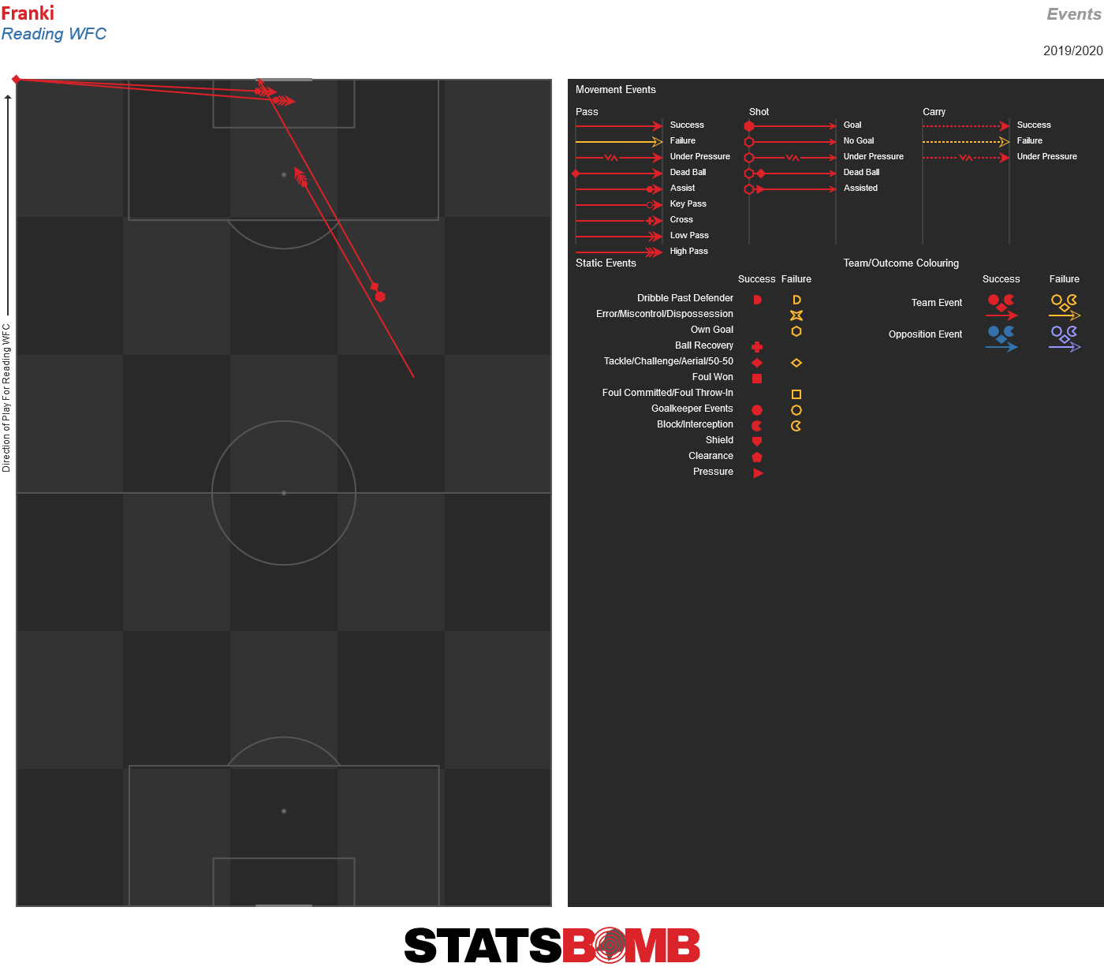

Thirty-six percent of Reading’s expected goals come from set-pieces, the third-highest rate in the league and far, far higher than Bristol’s, which is down at 12%. One feels that Bristol, with such a low attacking production as a whole, might be leaving something on the table by not creating more from set-plays.

Bristol are not without promising players. 22-year-old goalkeeper Sophie Baggaley has won a lot of fans over the past couple of years, as has defender Meaghan Sargeant (for similar ‘strong defensive players on struggling team’ reasons), and 18-year-old forward Ebony Salmon has been exciting in her, generally brief, appearances this season.

But the likelihood is that this will be a pleasant game for Reading to host at the Madjeski stadium on women’s football weekend. And, given the other tough matches set up for this round of games, a Reading win could see them leap up to fifth.